**Install Jenkins on Red Hat Linux - Offline**

**Install Java**

1. Check what version of java is installed on the machine

Java -version

1. If your version of installed java is different, then uninstall it using:

sudo yum uninstall java -y

1. After this install java using:

sudo yum install java-1.8.0-openjdk.x86_64 -y

1. Set Java environment variable
2. Login to your account and open .bash_profile file

vi ~/.bash_profile

1. Set JAVA_HOME and PATH

export JAVA_HOME="/usr/lib/jvm/java-1.8.0-openjdk-1.8.0.212.b04-1.el8_0.x86_64"

export PATH=$PATH:$JAVA_HOME/jre/bin

1. Type the following command to activate the new path settings immediately:

source ~/.bash_profile

1. Verify the paths

echo $JAVA_HOME

echo $PATH

**Install Jenkins**

1. Download the RPM key for jenkins from <https://jenkins-ci.org/redhat/jenkins-ci.org.key> to your local machine.
2. Download the latest RPM file for Jenkins from <https://pkg.jenkins.io/redhat-stable/> to your local machine. Eg : jenkins-2.164.3-1.1.noarch.rpm
3. Using the Winscp or some other tool transfer the above downloaded files to the Linux VM
4. Import a key file from Jenkins-CI to enable installation from the package

sudo rpm --import jenkins-ci.org.key

1. Install Jenkins using the following command

sudo yum install jenkins-2.164.3-1.1.noarch.rpm -y

1. Once you are done with the above steps, Jenkins will be installed in /var/lib/jenkins folder. Do note that /var/lib/jenkins will be empty at this time.
2. You will also be able to see the jenkins.war file in /usr/lib/jenkins folder

ls -ahl /usr/lib/jenkins

1. Start Jenkins as a service

sudo service jenkins start

sudo service jenkins status

sudo chkconfig jenkins on

1. Enable the Jenkins service to start on system boot

sudo systemctl enable jenkins

1. Check whether it started successfully run

sudo systemctl status jenkins

**Setting Up Jenkins**

1. Browse to http://localhost:8080 (or whichever port you configured for Jenkins when installing it) and wait until the Unlock Jenkins page appears. 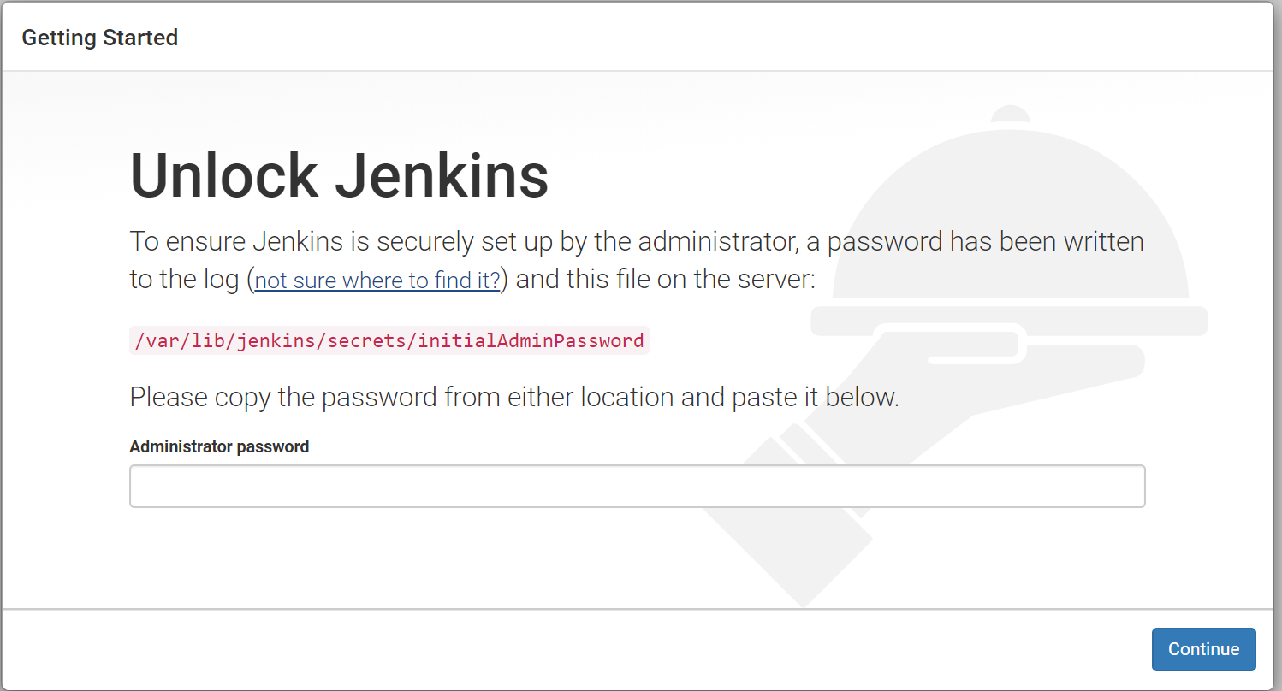
2. Use the following command to print the password on your terminal:

sudo cat /var/lib/jenkins/secrets/initialAdminPassword

1. Copy the password from your terminal, paste it into the Administrator password field and click Continue.
2. Next window prompts to install the plugins for Jenkins since there is no internet access from Linux VM. Click on X and close the window for now.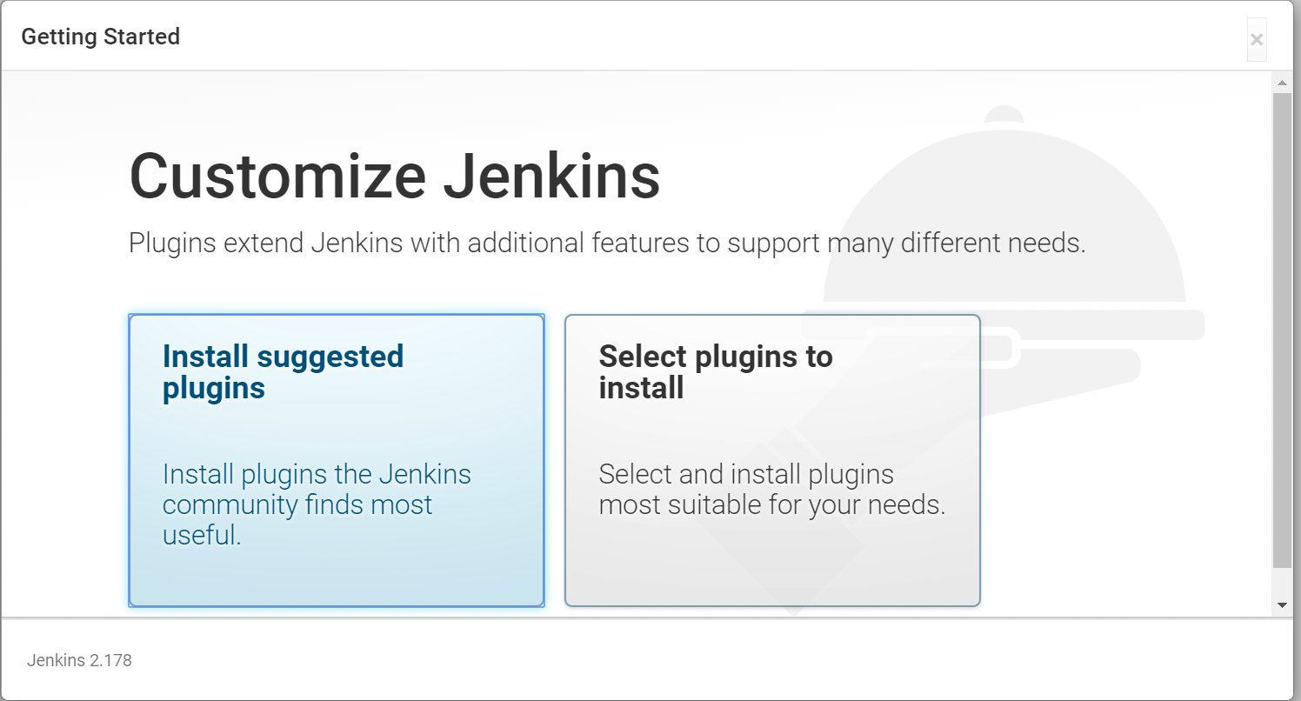
3. After closing the previous window, it shows the following screen. Click on Start using Jenkins.

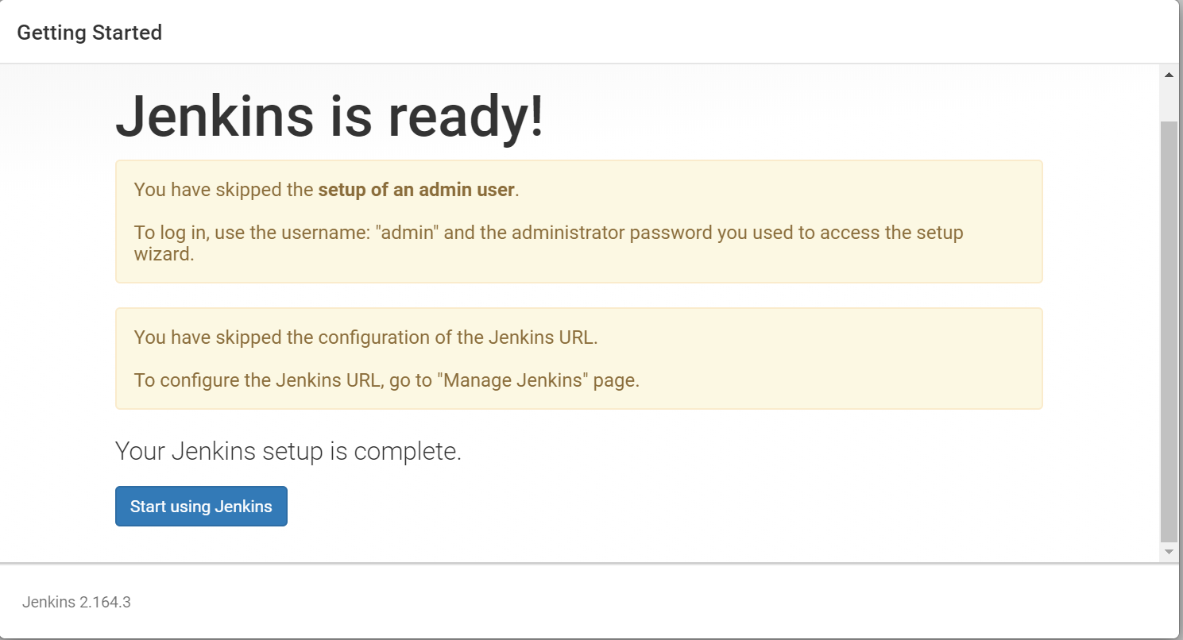

1. It redirects you to the Jenkins page.

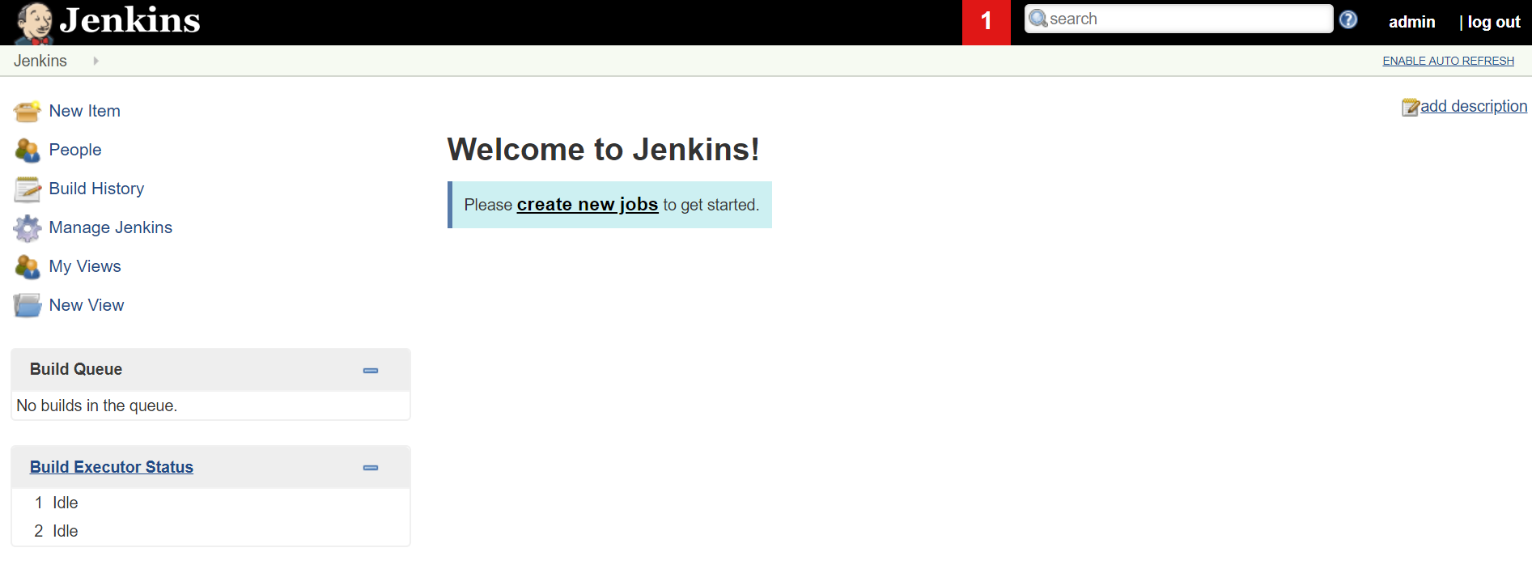

**Setup Jenkins Plugins in Offline Mode**

To install plugins in offline mode, you have to download the .hpi plugin file from [**https://updates.jenkins-ci.org/download/plugins/**](https://updates.jenkins-ci.org/download/plugins/). However, if you go this route, you will have to download the dependencies too, which can make this task near impossible. The easier way is to

1. Install Jenkins and the related plugins on your workstation, or any other machine (It can be Windows machine too).
2. Once all the plugins are downloaded, you can copy the plugins folder from the workstation to the Jenkins server /var/lib/jenkins folder.
3. After you copy, just stop and start Jenkins, and you will see that all your plugins are installed.

**Creating the first administrator user**

Please follow the steps from the following link <https://medium.com/@anusha.sharma3010/creating-managing-multiple-users-in-jenkins-b68ba7dc0810>

**Troubleshooting**

1. **Configure the firewall**

firewall-cmd --permanent --new-service=jenkins

firewall-cmd --permanent --service=jenkins --set-short="Jenkins Service Ports"

firewall-cmd --permanent --service=jenkins --set-description="Jenkins service firewalld port exceptions"

firewall-cmd --permanent --service=jenkins --add-port=8080/tcp

firewall-cmd --permanent --add-service=jenkins

firewall-cmd --zone=public --add-service=http --permanent

firewall-cmd --reload

firewall-cmd --list-all

1. **Uninstall Jenkins**

sudo yum remove jenkins

**Reference**

Install Jenkins –

<https://jenkins.io/doc/book/installing/>

<https://linuxize.com/post/how-to-install-jenkins-on-centos-7/#setting-up-jenkins>

<https://medium.com/@mohan08p/install-and-configure-jenkins-on-amazon-ami-8617f0816444>